
Utilization of review form process or form 360 review employee performance in company using Configure Change Engine

H. Suhada¹, Aditiya Lityanian Al Nasir², Andhika Dwi Putra³
Universitas Raharja^{1,2,,3}
Indonesia


e-mail: suhada@raharja.info¹, aditya.lityanian@raharja.info² , andhika.dwi@raharja.info³

(APA style, Justify, Arial 10pt) Example:
To cite this document:
Zarlis, M., Harahap, E., & Husna, L. (2019). Test Appraisal System Application Based on YII Framework as Media Input Student Value Final Project and Thesis Session at Higher Education. Aptisi Transactions On Technopreneurship (ATT), 1(1), 82-93. Retrieved from https://pandawan.aptisi.or.id/index.php/att/article/view/59

Abstract

In building a company, which needs to be considered and very important is the accounting system, because to take a decision for the advancement of a company can use a rules-based system to configure products in the company. In today's modern era, the company's staff can access rules-based systems to configure products wherever and whenever they are connected to the Internet. This discovery provides the ability to test rules in system-based rules to configure the product. The configuration system defines the product component by using the elements contained in the catalog section and the rules that define the relationship between the product components. The user provides a test case that selects at least one section to include in the product configuration, and the configuration tester processes the rule to determine if at least one section is selected in case of a conflict test with the previous part of the plurality included in the product configuration.

Keywords: configure Change Engine, Product System, Settings

1. Introduction
In today's modern era, it is undeniable that technological developments have been very rapidly even entering the product configuration field. Continuous system development makes the product configuration system significantly improved, from the start that runs using manual or offline. Now, it can run online with internet connected.
As a first step to using the product configuration system, the initial settings are indispensable. It is to display information about the company. As the use of the configuration system defines the company's valid product components, what is the use of the product configuration system used by the company, and much more. Using the setting menu can allow the company's administrators to add information about the company to make it easier to communicate.
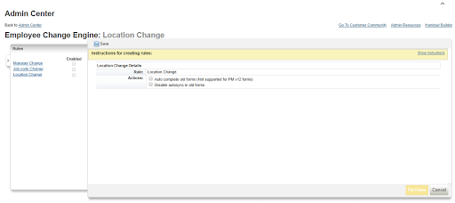

2. Research Method
This invention relates generally to computerized configuring systems. More specifically, this invention relates to a system and method for testing the compatibility of parts included in a configuration.

2.1 Literature Review
1. A method of using a computer system to test a product configuration for configuration errors, wherein the product configuration is stored as electronic data in a computer system for generating product configurations, the computer system including at least one rule defining a relationship between at least two parts, the product configuration including a plurality of parts, the method comprising:
entering a test case into the computer system to detect configuration errors in the product configuration, wherein the test case includes data to change the product configuration;
processing the test case with the computer system in accordance with the at least one rule to detect whether the change in the product configuration, as a result of processing the test case in accordance with the at least one rule, produced a configuration error in the product configuration; and
generating explanation data with the computer system to provide an explanation of any detected configuration error in the product configuration.
2. The method, as set forth in claim 1, wherein processing the test case, further includes:
- initializing the computer system with a part state;
- inputting at least one part selection to change the product configuration; and
- listening to state change events in the system to detect when a state change event occurs that results in the computer system being in the initialized part state.

3. The method, as set forth in claim 2, wherein generating explanation data, further includes: generating explanation data that explains the part state in terms of the state change event.
4. The method, as set forth in claim 3, wherein processing the test case, further includes: generating a new part state for each part associated with the chance in the product configuration.
5. The method, as set forth in claim 4 wherein processing the test case further includes: determining causes that explain the new part states in terms of the state change event.
6. The method, as set forth in claim 5 wherein generating explanation data further comprises:
generating a cause tree wherein the root of the cause tree is the initial part state and leaves of the tree are the user's selections of parts.
7. The method, as set forth in claim 6 wherein generating explanation data comprises further comprises:
generating an explanation of the part state wherein the part selections are the root of the explanation data and the causes follow from the part selections.
8. The method, as set forth in claim 7, further comprising:
sorting the tree by iteration number, wherein the iteration number of a part state is determined by measuring the longest distance between the part state and the cause corresponding to the part state.
9. The method, as set forth in claim 1, wherein the explanation data is based on selection of a part.
10. The method, as set forth in claim 1, wherein the explanation data is based on execution of a rule.

3. Findings

In one embodiment of a configuration system disclosed in the '651 patent, a framework for defining a product line includes a set of related components that are selected from a parts catalog. A product might consist of several hundred individual parts that are organized into part groups and are available on one or more of a number of products. A product is modeled by describing which parts and part groups are available in that product and which choices must be made from within the part groups, and then by writing additional rules that describe part-to-part relationships which are not modeled by the product structure. A compiler converts the product structure and the rules into four rule types: includes (parts that are included by default), excludes, removes, and requires choice (a choice among a group of parts that must be made to achieve a valid configuration). Parts may also be classified as optional which signifies that they can be optionally included in the configuration.

3.1 Problem

In today's modern era, it is not undeniable that the development of technology in the world is growing rapidly. System development to determine the progress experienced a significant official, which from the beginning only run manually or runs offline now the system can run online with Internet connection.

3.2 Research Implementation

In addition to organizing or adding questions about the company. To make it easier for the company to manage its tasks with the Change Engine configuration, companies can also manage their employees performance by means of product formats, user formats, and template formats.

How do we determine the rules?

- On the left, click the rule we want to set. There are Manager, Job Code, and Location rules

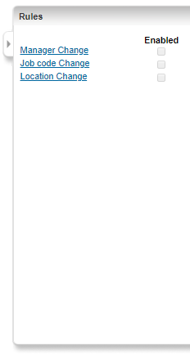
Picture 1. Performance Rule View

2. Then after selecting the middle rule in the Action/Action section, select the action we want to run when the changes occur. Each rule has different actions.

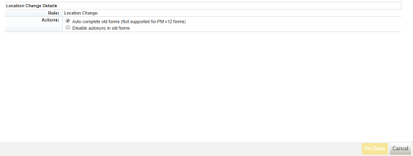
Picture 2. Location Charger Detail

3. Once done, click I'm Done to save the preset settings and we will be redirected back to the Admin Center page or click Save located at the top to set more rules.

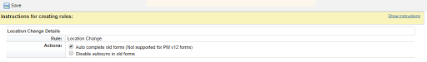
Picture 3. Instructor for rules

After we save the preset settings, when we reopen the Configure Change Engine page then the left place 3 of the rules will be choke. If we set the three then the three will choke, but when we set one of them then only the one that is concunked.

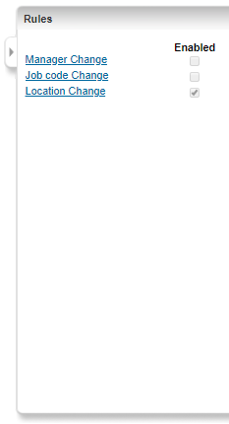

4. Conclusion

From the discussion that has been outlined above, the authors can draw conclusions, the use of Configure Change Engine a page that is useful to set a rule that determines the progress/process of review form or the 360 review form of employee performance on the Success Factor website. Very useful and makes it easy for companies to do their job later. The company's initial information settings are also very easy as described above. By using the system Configure Change Engine can create a system/Process review form or form 360 review of employee performance, the company more efficient and more effective, especially for companies who are very busy in organizing their employees. So that the company can be neatly arranged and well controlled.

References

[1] Gilpin, K. E., & Stein, A. R. (2004). U.S. Patent No. 6,836,766. Washington, DC: U.S.
Patent and Trademark Office.

[2] Sulistyo W, Chandra DW. Desain Sistem Penyebaran Informasi yang Efisien ÿengan Memanfaatkan Teknologi Informasi di Pemerintah Kota Salatiga.

[3] Rahardja U, Aini Q, Khoirunisa A. Implementasi Business Intelligence Menggunakan Highchart pada Sistem Penilaian Absensi berbasis YII Framework. CSRID (Computer Science Research and Its Development Journal). 2017 Jun 7;9(2):115-24.

[4] Handayani I, Warsito AB, Pangestu SA. PEMANFAATAN WEBSITE RAHARJA. AC. ID SEBAGAI MEDIA INFORMASI DAN UPLOAD ARTIKEL UNTUK NS-CCIT MENGGUNAKAN FRAMEWORK YII. CCIT Journal. 2017;10(1):127-38.

[5] Rahardja U, Harahap EP, Pratiwi S. Pemanfaatan Mailchimp Sebagai Trend Penyebaran Informasi Pembayaran Bagi Mahasiswa Di Perguruan Tinggi. Technomedia Journal. 2018 Apr 22;2(2):38-51.

[6] Aini, Q., Zaharuddin, Z., & Yuliana, Y. (2018). Compilation of Criteria for Types of Data Collection in Management of Research Methods. Aptisi Transactions on Management (ATM), 2(2), 97-103.

[7] Aryani, D., Aini, Q., & Armansyah, F. S. (2017). Perancangan Android Package Mobile Web pada Sistem Penilaian di Perguruan Tinggi. SISFOTENIKA, 7(2), 155-166.

[8] Aini, Q., Rahardja, U., & Naufal, R. S. (2018). Penerapan Single Sign On dengan Google pada Website berbasis YII Framework. Sisfotenika, 8(1), 57-68.

[9] Rahardja, U., Aini, Q., & Thalia, M. B. (2018). Penerapan Menu Konfirmasi Pembayaran Online Berbasis Yii pada Perguruan Tinggi. Creative Information Technology Journal, 4(3), 174-185.

[10] Agustina, I. I., Handayani, I., Aini, Q., & Cholisoh, N. (2018). Pemanfaatan Google Form Sebagai Pendaftaran TOEFL (Test Of English as a Foreign Language) Secara Online. Jurnal Teknoinfo, 12(2), 18-22.

